SIMATS ENGINEERING
ASSESSMENT TOOL 2 - Medium(Assignment 1)
COURSE CODE: CSA09 COURSE NAME: Programming in Java COURSE OUTCOME COVERED
CO2: Implement Collection Framework interfaces such as List, ArrayList, Set, Map, HashTable, and HashMap using iterators and generics to store, retrieve, and process groups of objects in web applications.(BL3,BL4)
Assessment Tool Weightage: 10%
QUESTIONS: 40 (each student assigned distinct questions) Total Marks: 100
ANNEXURE A
Assignment 1
Code of Conduct:
I K. Amrutha Sandhya 192524270(Name / Reg No) certify that this submission is my original work and that I have adhered to the guidelines specified for this assessment.
I understand that any violation of academic integrity rules will result in disciplinary action.
Signature of the student:
Amrutha
RUBRICS FOR CALCULATION:
Criteria | Level 4 (Exemplary) | Level 3 (Proficient) | Level 2 (Developing) | Level 1 (Beginning)
Problem Understanding
Algorithm
Code Implementation
Competitive Performance
Test Case Handling

Question 39 – Smart Hospital Equipment Registry

Problem Statement:
A hospital tracks medical equipment across departments.

Questions
a) Develop a Java program using Generics to manage different equipment types.
public class Equipment<T> {
T item;
Equipment(T item) {
this.item = item;
}
void display() {
System.out.println("Equipment: " + item);
}
public static <T> void searchEquipment(T item) {
System.out.println("Equipment Found: " + item);
}
public static void main(String[] args) {
Equipment<String> e1 = new Equipment<>("ECG Machine");
Equipment<String> e2 = new Equipment<>("Ventilator");
Equipment<Integer> e3 = new Equipment<>(101);
e1.display();
e2.display();
e3.display();
searchEquipment("Ventilator");
searchEquipment(101);
}
}
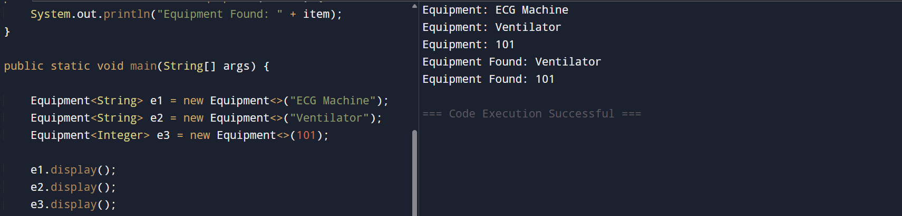
b) Implement generic methods to search equipment details.
public class EquipmentSearch {
// Generic Method
public static <T> void searchEquipment(T equipment) {
System.out.println("Equipment Found: " + equipment);
}
public static void main(String[] args) {
searchEquipment("Ventilator");
searchEquipment("ECG Machine");
searchEquipment(101);
}
}
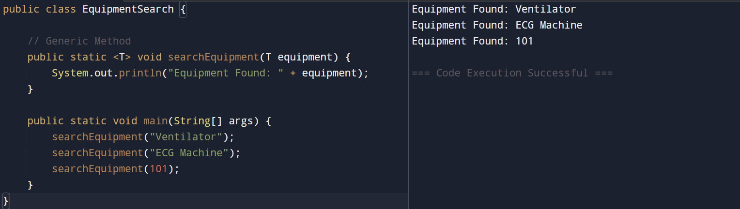

c) Compare generic classes and generic methods.
Generic Class | Generic Method
A class with a type parameter. | A method with a type parameter.
Used to create objects of different data types. | Used to perform operations on different data types.
Type is specified when creating the object. | Type is specified when calling the method.
Example: class Equipment<T> | Example: public static <T> void search(T item)

d) Explain the importance of type-safe programming in healthcare software.
- Prevents data type errors at compile time.
- Ensures accurate handling of patient and medical equipment data.
- Reduces runtime errors and improves software reliability.
- Improves code reusability and maintainability.
- Enhances patient safety by minimizing programming mistakes.

